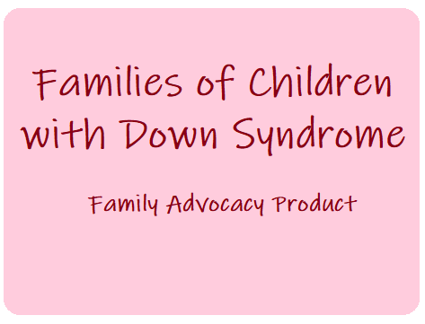

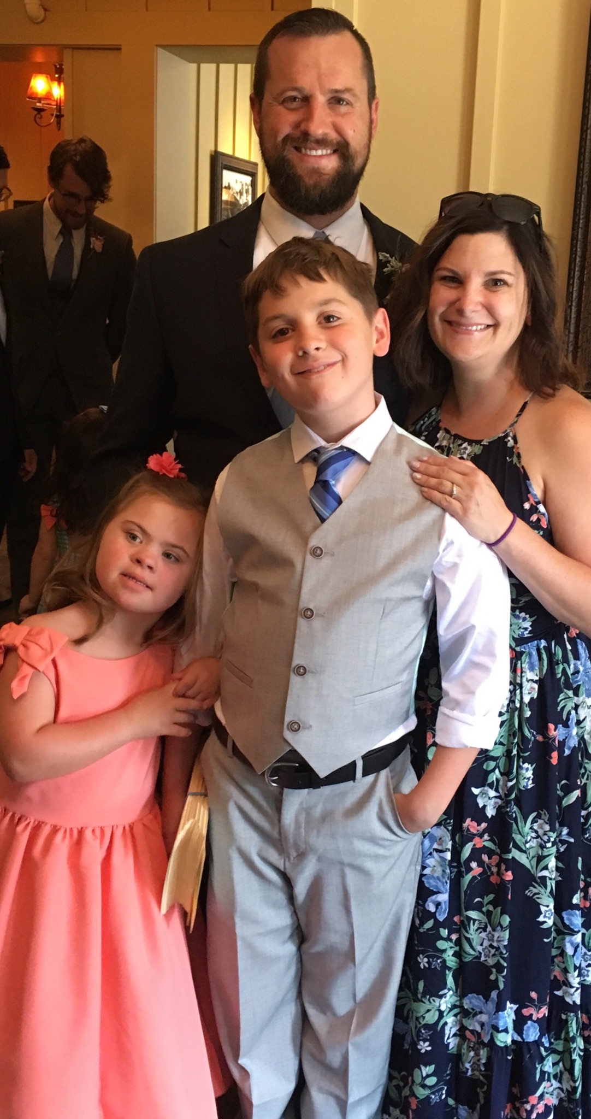

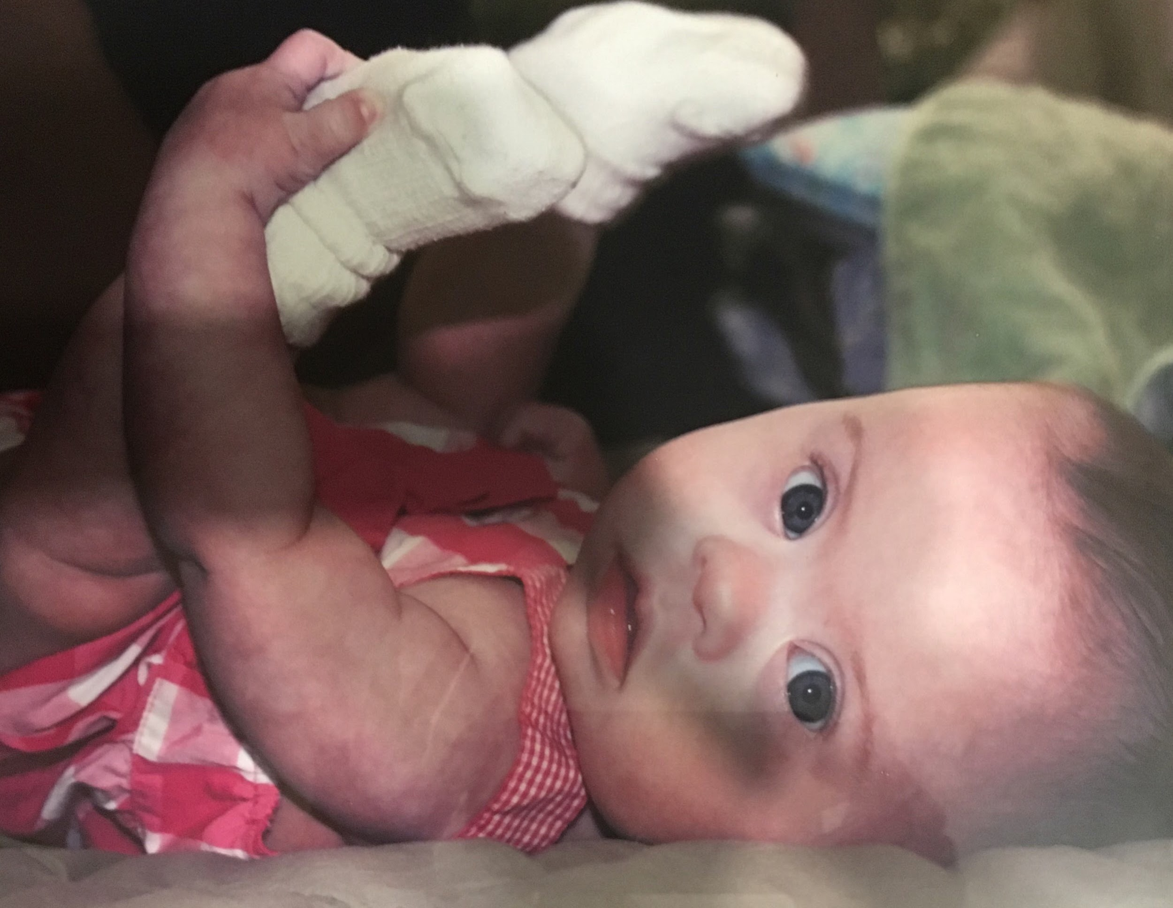

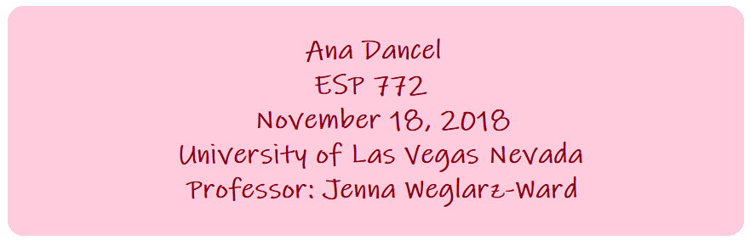

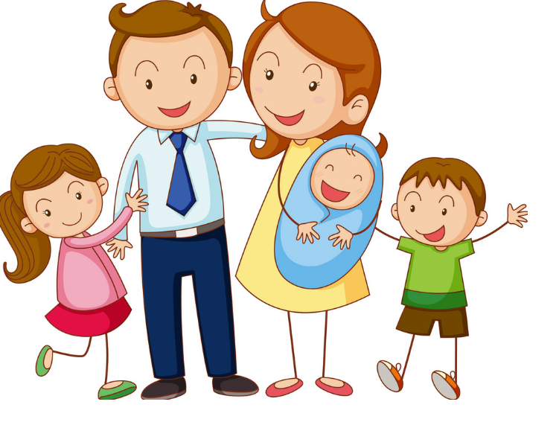
What is Family Advocacy?
Family advocacy can relate to families that are experiencing challenges such as developmental disabilities, homelessness, abuse and neglect, families in the military, and many more. This handout focuses on families of children with Down syndrome.

What is Down Syndrome?
Down syndrome is also known as Trisomy 21. DS is a condition in which a person is born with an extra chromosome. The extra chromosome causes delays in the way a child develops mentally and physically. There is no way to prevent Down syndrome, but it can be detected before a child is born (KidsHealth, 2018).

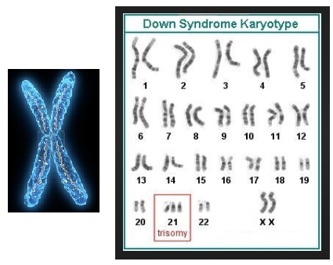

Why we must acknowledge families of children with Down syndrome:
- There are families in need of help
- Families need resources
- Families need support
- We should help raise awareness

Resources
Best Buddies
This is a nonprofit organization committed in creating opportunities for volunteers to make one-to-one friendships, integrated employment and leadership development for people with intellectual and developmental disabilities. This organization serves people with disabilities of that including Down syndrome.
Link: https://www.bestbuddies.org/nevada/


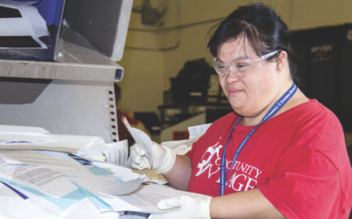
Opportunity Village
This organization is located in Southern Nevada and serves adults with intellectual and related disabilities to enhance their lives and the lives of families who love them. Opportunity Village allows people with severe disabilities to find new friends, unleash their passion, think of their future, find independence, and enhance community integration.
Link: https://www.opportunityvillage.org/

National Down Syndrome Congress
The NDSC is dedicated in supporting and providing crucial information for anyone touched by or seeking to learn about Down syndrome. Their motto is to educate, advocate, empower, and inspire. They believe in the children, demand their rights, and get them affirmed.
Link: https://www.ndsccenter.org/
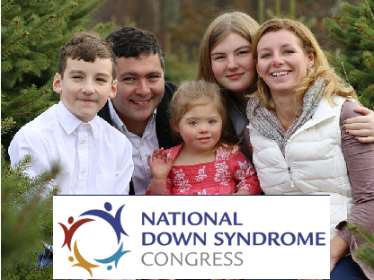

National Association for Down Syndrome
NADS generates individuals with Down syndrome to be accepted by their families and communities, to develop their capabilities, and to work towards independence. This program provides support for individuals with DS in achieving their full potential. This source includes information and resources to help people access appropriate services, educates the public about DS, addresses social policy issues and challenges, and facilitates families.
Link: https://www.nads.org/

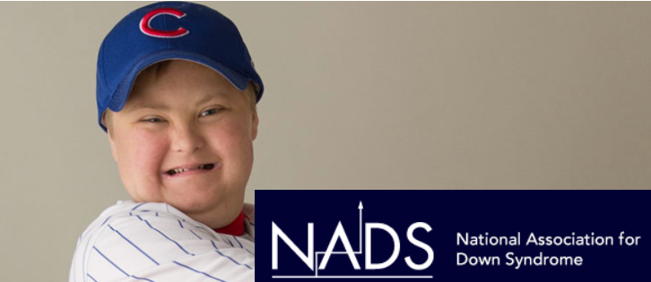

BOOKS
D is for Down Syndrome A Child’s View
Written by, Amy E. Sturkey, Pt
Illustrated by, Ikos Ronzkie
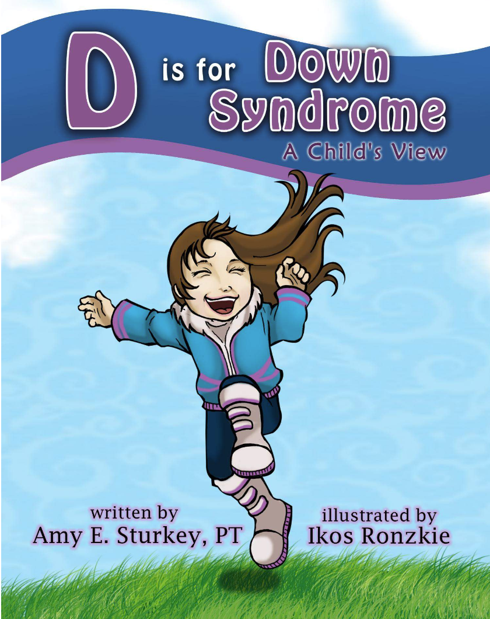

This children’s book uses an ABC format that helps children understand more about Down syndrome through a child’s perspective. The book includes typical traits that many people with DS share. Reading this provides wonderful opportunities to engage in conversation with all children.
The book is relevant, because not only does it provide delightful illustrations but the book is informative and an easy read for children, friends, family members, and all who wants to learn about Down syndrome.

Link: https://www.amazon.com/Down-Syndrome-Childs-Childhood-Challenges-ebook/dp/B075CD2MJV/ref=tmm_kin_swatch_0?_encoding=UTF8&qid=1542583387&sr=8-3

Chromosome Kids Like Me
Written by, Annette Fournier
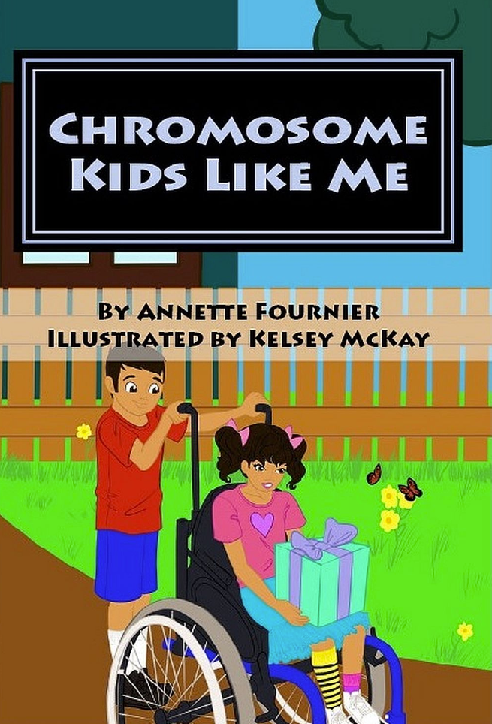
Illustrated by, Kelsey McKay

This book is a sweet story that takes something complex--understanding chromosome disorders--and compares it to something we can all understand. The book is a great way to teach children and adults about rare chromosome abnormalities and helps people see how people who have them are special. This book is a fun and easy read for families of children with Down syndrome and an excellent teaching resource.

Link: https://www.amazon.com/dp/B07D1ZBTM7/ref=rdr_kindle_ext_tmb

Down Syndrome Parenting 101 Must-Have Advice for Making Your Life Easier
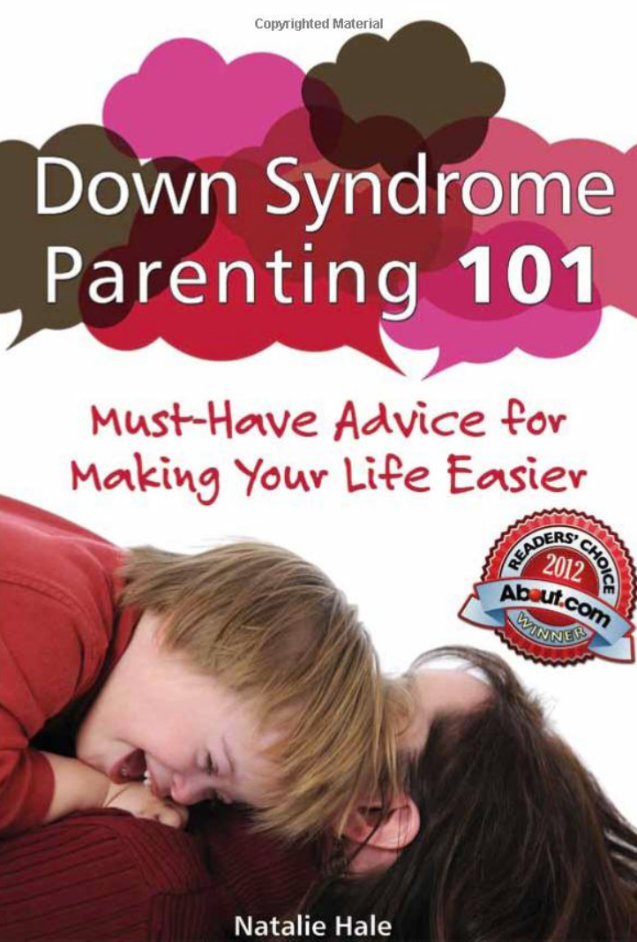
Written by, Natalie Hale

This chapter book provides uplifting and indispensable advice and best practices from the author's personal and professional experiences. The book reveals issues children with DS may face, various life stages they go through, experiences, and people they will encounter. This straightforward and sensible book would be relevant for parents, grandparents, teachers, and anyone who shares life with a person with Down syndrome.

Link:
https://www.amazon.com/Down-Syndrome-Parenting-101-Must-Have/dp/160613020X/ref=sr_1_8/134-1094504-4362837?ie=UTF8&qid=1542583203&sr=8-8&keywords=down+syndrome+books

Quick Contact
Name: Ana Dancel
Feel free to email and or call if you have anymore questions, thoughts, and or concerns!
Email: FamilyAdvocacyDS@gmail.com
Phone: (702) 316-4590
To stay updated on resources and information, visit my website or follow me on Twitter!
Website: https://familyadvocacyds.webnode.com/
Twitter: https://twitter.com/FamAdvocacyDS @famadvocacyDS

